FOUNDATION FOR VIRTUAL AND AUGMENTED REALITY SYSTEMS
Lecture33
Lec-33: Introduction to Majuli case study
Welcome to the NPTEL MOOC's course on Foundations of Virtual and Augmented Reality Systems. We are going to start a new topic on the introduction to a case study. Now, so far what we have done, let us quickly go through what we have learned so far. So far, we got basic knowledge on various aspects of AR. Now, we are in a position to tell that we know basics of extended reality systems, what it is, what are the challenges, what are the issues and so on.
Now, what remains is how to build such a system. So, in the previous few lectures, we talked about the interactive systems, concerns of usability and what kind of software development lifecycle we can follow to build interactive systems. XR systems are examples of interactive systems. So, essentially we can follow the same system development lifecycle to build extended reality systems.
In the next few lectures, we will try to understand this development process, system development process, with the help of a case study, a practical system. Now in this lecture, we are going to introduce that case which we are going to study to understand different aspects of system development. Now let us talk about the case. So the case is on digital preservation of physical heritage, where we will be talking about the physical space of the Majuli River Island and we will be talking about how to preserve the heritage of this island in the digital space.
So, that will be our case. So, the case study will focus on design, implementation, and evaluation of An extended reality system. In this case, it will be a virtual reality system to digitally preserve the Majuli River Islands' ecological and cultural heritage. That will be our case, which we are going to elaborate on in subsequent lectures to explain different aspects of interactive system development as discussed during the
understanding of the interactive system development life cycle. Let us first try to understand the case that is the Majuli River Island and why we want to preserve it. So, this is a river island that is on the Brahmaputra River in Northeast India. It is considered to be the world's largest inhabited river island and a potential UNESCO World Heritage Site contender. Now, geographically, it is located in the state of Assam in Northeast India.
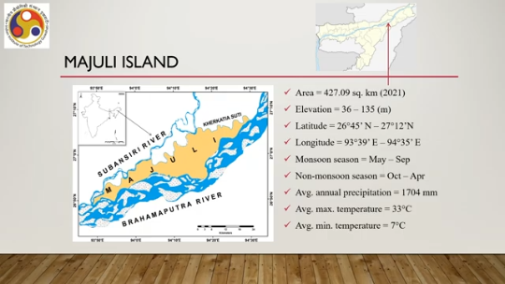
As you can see here, it is located somewhere here on this map of India. Now, the island is shown here in yellow color. It is surrounded by rivers. One side is the Brahmaputra, other sides are other rivers. And it has about 427.09 square kilometers of area as per 2021 data.
Another way to visualize it within the state of Assam is shown here as you can see this region here is the island is towards the eastern part of Assam. So, there are several topographical and geological characteristics: elevation, latitude, longitude. Typically, May to September is considered to be the monsoon season, and why the monsoon is important we will soon see. October to April is the non-monsoon season. Average annual precipitation is 1704 millimeters, maximum temperature is 33 degrees Celsius average, and minimum is 7 degrees Celsius. These are some of the geographical and geological characteristics of the island.
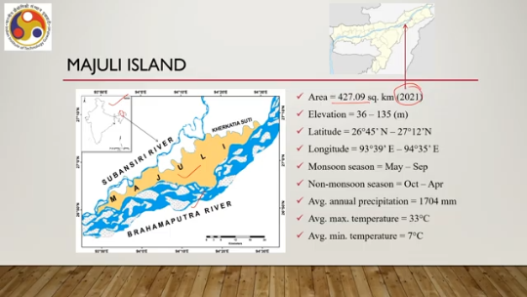
Why is this important from the point of view of heritage preservation? So, what is so special about the island? So, the island gained its distinction due to a number of natural and cultural attributes. It has a unique topography because of its unique position, which contributed to a unique ecological setup. And it also led to a distinctive integration of man and nature.
One important heritage aspect of Majuli is the Satra or Vaishnavite monasteries. Now, these are considered to be authoritative centers of Vaishnavite faith in Assam, and they are living workshops of different kinds of visual and performing arts. Some photos of different Satras are shown here. Also, the island is home to several tribal communities, including three distinctive tribal communities: Mising, Deori, and Sonowal Kachari. So, these three are distinctive tribal communities who inhabit the island.
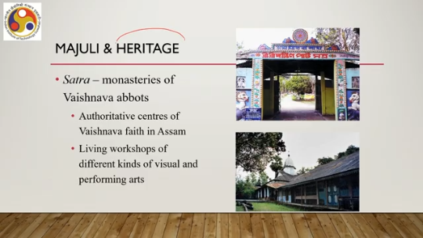
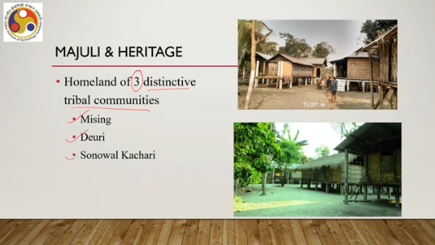
As you can see, there is uniqueness in their way of living, in their rituals, heritage, culture, and many other things. So, they have their own traditional repertoires of living, which makes it unique. Now, when we talk of the heritage of Majuli, this heritage can be of two types: one is the tangible heritage such as cultural artifacts like masks, musical instruments which we can touch, which we can feel by touching, then the architectural aspects of satras, traditional tribal homes
architectural aspects of such homes, and so on. So, these tangible heritage aspects essentially refer to heritage aspects of the island which someone can touch and feel. Then there are intangible heritage aspects which cannot be touched and felt, but they can be sensed through different means. The part of intangible heritage includes traditional skills, knowledge, and aesthetic norms in music, dance forms, drama or performing arts, mask making, vernacular architecture, weaving, food, and agricultural practices, and so on.
kind of things such as music, dance forms or performing arts, the process of mask making, aspects of vernacular architecture, weaving process, practices to grow food and agricultural practices. These are something which we cannot actually touch. They are kind of intangible, but there is uniqueness in such intangible things as well and those need to be preserved as well. Now these are typically embedded in the daily and occasional activities of social life. So those are two broad aspects of heritage that are part of cultural heritage.
Now along with that, there is ecological heritage, flora and fauna of the island which are there due to its unique geology, unique geography. unique topography because of the natural formation. Now the question is, so far so good, all are there. Now why do we need to go for digital preservation? We have to note that the island has been constantly hit by severe annual floods and erosion.
So it is eroding. This endangers not only the rich cultural resources, but also the very material existence of the island itself. So there is a possibility that the island may disappear in the future. And what gives us a clue to that possibility? We can see, starting from 1917 and up to 2010, how the island has eroded.
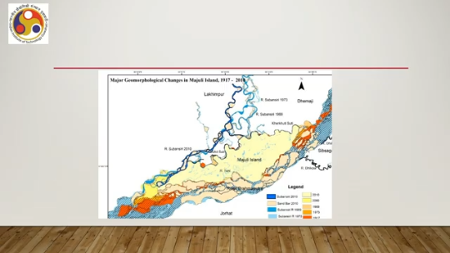
And how the area where people live has eroded over a period of time. So, these parts, as you can see, were part of the island in 1917, but they are no longer part of the island in 2010. Similarly, these areas, these areas, these areas have disappeared. Whereas earlier people used to live or those were habitable, but now they have been reduced to sandbars and river banks. So, slowly the river is consuming the island and reducing the habitable area.
If we look at the statistics, we can see that at the beginning of the last century, around 1900, the size of the island was about 1250 square kilometers. In 1975, 75 years down the line, the size had reduced by more than half, to about 570 square kilometers. And by 2021, it had further reduced; now the current size is about 427 square kilometers. So, it is a huge reduction. From 1975 to 2021, you can see that within these 46 years, about a 25 percent reduction has taken place in the island's size.
Starting from the last century, that is 1900, we can see that from 1250 square kilometers, it has come to 427 square kilometers. Almost two-thirds of the island is gone. This is based on this reference. Now, if that is the case, then certainly it is a cause for worry. This is another way of visualizing the erosion and the current state.
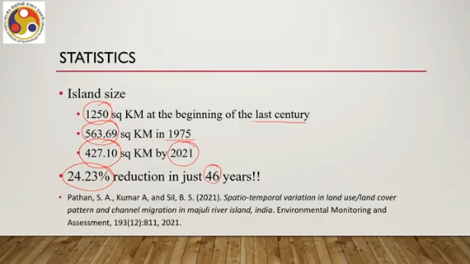
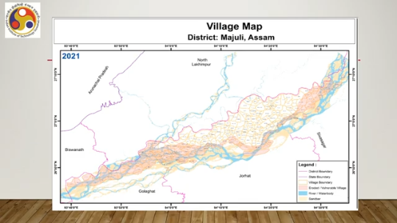
So, this entire region is considered to be eroded, which was once upon a time habitable, but it is no longer habitable now. The major part is underwater and some parts have become sandbars and barren. There is a very real possibility going by the statistics. Of course, there are measures being taken to prevent further erosion, but still there is a possibility that this island may disappear in the future. Now, before the island disappears completely, it is, of course,
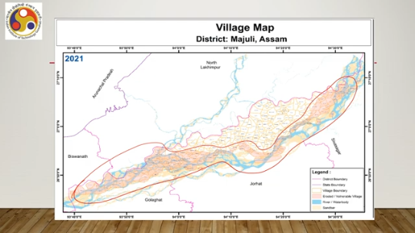
essential that we preserve its tangible and intangible heritage along with the ecological heritage. Now, when you talk of heritage preservation, what are the traditional ways of preserving heritage? Let us only talk about cultural heritage preservation, not ecological. We can rely on oral traditions, museums, maintenance of historical sites, and documentation. Now, maintaining historical sites, of course, in this case is out of the question because we are assuming that the island may disappear in the future or may get further eroded.
So, historical site preservation may not be possible. Now those are traditional methods. If we go for digital preservation, preserving the same things in the digital universe, in digital form, then generally that leads to a more engaging experience for the users while accessing the heritage. Now digital preservation is defined by UNESCO as using digital media to preserve
educational, scientific and other resources. So, when we talk of digital heritage preservation, we are essentially referring to the process of using digital media to preserve the heritage. It may be cultural, may be educational, may be scientific, may be ecological, may be anything else. And it involves archiving. digitizing and using immersive technologies like VR and AR.
So, essentially the very definition of digital heritage preservation involves or refers to the use of immersive technologies like VR or AR along with other aspects of digitization such as archiving the information. Now when we talk of archiving that means storing the visual and audio files which capture the information heritage information of a particular entity, object, space or place. Then immersive technologies can be used to create in the virtual world the same space like a virtual tour enhancing user experience.
As we all know that this immersive experience is supposed to be more engaging as compared to just accessing some information through a computer screen. It can also provide an interactive experience. The users can interact with the entities in the virtual world if properly designed, which increases the engagement. In the digital space, by creating digital avatars of the elements and objects of the physical space, we can preserve the fragile artifacts that may not survive the passage of time.
But in the digital space, by creating digital avatars, we should be able to preserve those. Also, immersive technologies can enable a global audience to explore heritage sites and intangible aspects of culture sitting right at their home without ever venturing out to the particular place. So in this case, that is one of the major objectives to preserve the island before it disappears so that future generations can access it even without visiting the island.
So, essentially we will be focusing on creating a VR experience for Majuli River Island with the aim to preserve the cultural and ecological heritage. Now, what can VR do? It permits users to access content remotely, opening doors for individuals worldwide to explore heritage sites and artifacts from the comfort of their homes. So, the users do not need to come to the site. It is known that such usage of virtual reality technologies or even any other immersive technologies
plays a pivotal role in promoting preservation of heritage for the benefit of future generations. So, that is why we should go for digital heritage preservation with immersive technologies. Now, let us try to understand what it means to have a VR experience for Majuli River Island. So, what do we want with this VR experience? We want a system that helps to preserve heritage and experience heritage.
So, there are two clear-cut goals. One is to preserve it, and the second one is to let it be experienced by users anywhere on earth. Now, when we talk about heritage preservation, what we mean is that we are going to create an archive of heritage information which ideally should be in the form of multimedia comprising images, videos, audios, and texts. So, different sorts of media can be utilized to create the archive.
Images can be of different types. We can have 2D images, regular 2D images, 360-degree images. Similarly, for video: 2D, 360-degree; we can have audio; we can have text. Now, when we talk about experiencing the heritage, we are essentially referring to
a virtual tour or an exploration of the island utilizing the archival information. And in our case, we are looking to build a system that provides users with an immersive experience. So, that is what we are aiming to do. Let us summarize what we have just discussed. Our broader objective is to explain the different stages of virtual reality or augmented reality system development, which follows the interactive system development lifecycle.
In order to explain different stages, we will be making use of a case, a practical case or practical system development. Now, in this lecture, we are trying to understand the case. So, in this part of this lecture, we have introduced the case that is the digital heritage preservation of Majuli River Island. So, we talked about the river island, its tangible and intangible heritage aspects, and the need for preservation as well as how immersive technologies can help in more engaging preservation efforts.
In the next part of the lecture, we are going to talk about the key concerns or challenges in building the system, which in subsequent lectures will be related to different stages of the interactive system development lifecycle. So, looking forward to meeting you in the next part of this lecture. I hope you could follow the discussion. So thank you, goodbye, and happy learning.

